Climate Justice and Student Leadership Program
A global collaborative online program
Part 1: April 19 – May 24, 2023
Part 2: June+ 2023
Offered by: The University of British Columbia, Deakin University, Manipal Academy of Higher Education, Nanyang Technological University, Pontificia Universidad Católica de Chile, Monash University, Universidad de Buenos Aires
Application deadline: March 31, 2023
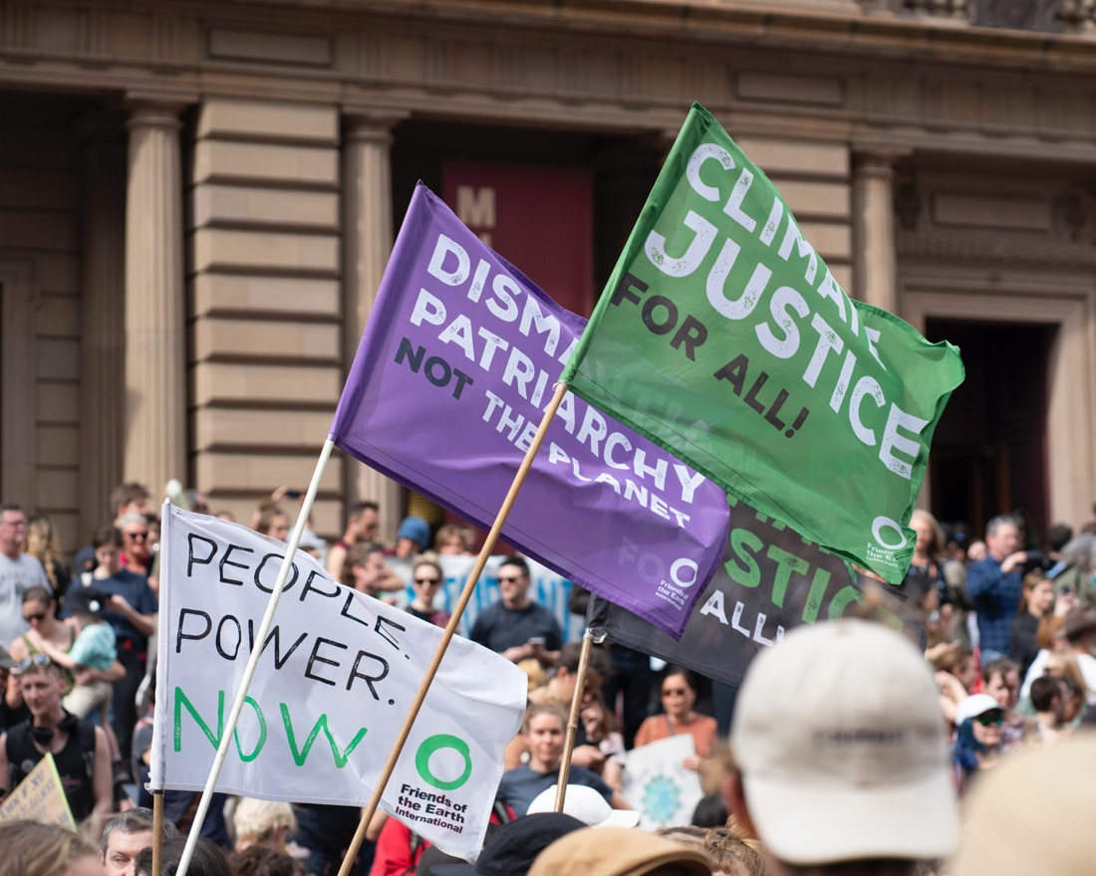
About the program
This pilot co-curricular program on climate justice and student leadership brings together universities in the Global North and the Global South to explore the linkages between climate change and inequality through a justice lens, and to develop globally-minded student leaders with a focus on local activism for global impact, and cross-cultural perspectives on climate justice.

Theme: The program will explore the implications of climate injustice at both local and global scale through the lens of power and privilege, and will develop students’ leadership capacities, intercultural, communications and design skills in order to mobilize students across participating institutions to take action through the lens of climate justice. The program framework is based in the three pillars for social change: Knowledge, Skills, and Action; and grounded in the values of: Empathy, Solidarity and Compassion.
UN SDG alignment: 13, 17, 4

Program dates:
- Phase one: April 19 – May 24, 2023
- Phase two: June+ 2023 (to be determined in consultation with the student cohort)

Benefits and learning outcomes:
- Gain key 21st century skills, including:
  - Intercultural knowledge and competence (communication, self-awareness, critical reflection)
  - Global citizenship (global knowledge and competence, social responsibility)
  - Transferable professional skills (navigating complexity, teamwork, problem-solving, application of learning in real world situations)
- Develop an understanding of climate justice, making connections to your lived experience and the UN Sustainable Development Goals
- Learn how local context shapes perspectives on and approaches to climate action
- Develop a critical attitude about personal and collective responsibility to confront the socio-environmental crisis
- Improve your knowledge about the climate emergency from the perspective of justice
- Practice thinking and working collaboratively in interdisciplinary and intercultural contexts
- Build a global network of peers and mentors
- Receive certificates of completion and recognition
- Gain future opportunities for international studies

Phase one (Training Program)
This small cohort Climate Justice Global Training Program, leading to a certificate of completion, includes the following components:
- Interactive online modules with a team of faculty and staff from partner universities:
  - Introduction to climate justice – global and local perspectives, case studies
  - Leadership – being a change agent, creating effective behaviour change, mobilizing peers around climate action with a justice lens
  - Communication – best practices in communication on climate change and climate justice, creating effective campaigns using social media
- Orientation to global virtual teamwork and intercultural collaboration
- Group work with support from faculty and staff mentors to develop a global, student-led social media campaign on climate justice by students, for students
- Group presentations with feedback from mentors

Phase two (Workshop/Event Design)
The second phase of the program will focus on the design and delivery of a global workshop on climate justice for a broad cross-section of students across the partner institutions, and leads to a certificate of recognition as a Climate Justice Global Leader.
Students may choose not to continue to phase two. At the end of phase one, interested student leaders will work with mentors to design the second part of the program, which will be student-led.
------------------------------------------------------------------
Mentors
-----------------------------------------------------------------
Student Eligibility
Up to 5 students will be selected from each participating institution for this pilot program. This program is open to undergraduate and graduate students across disciplines and year levels.
Successful applicants should demonstrate a strong academic performance, interest and experience in extra-curricular activities, and be a good team-player.
Ideal participants are:
- Local/ national leaders in the climate space, interested in taking their activism to the global level OR
- Highly motivated and literate/ engaged in climate action/ justice OR
- Highly motivated and possess a strong interest in the theme, but lack experience – able to contribute different perspectives

Expectations
- Participate in the entire training program
- Deliver a short individual presentation sharing climate justice approaches in your local context with the cohort
- Work with a small team of peers from other institutions to develop a social media campaign on climate justice
- Deliver a group presentation on your campaign
- Participate in a follow-up reflection session to integrate learning (or provide feedback via email/survey)
- Provide input into phase two (optional)
Estimated time commitment: 18-20 hours
- Pre-program assignment: 30 minutes
- Training program: 3 x 2-hour sessions, once a week over 3 weeks: 6 hours
- Additional team meetings with mentors as needed: 2 hours/week over 4 weeks: 8 hours
- Final presentation session: 2 hours
- Reflection session/ feedback and evaluation via email: 1 hour
- For students continuing on to phase two: additional sessions to plan the structure, design and delivery (TBD in consultation with participating students)
Note: this program necessitates out of hours commitment due to diverse time zones; modules and group meetings may take place early in the morning or late at night in some countries.
Times (2-hour sessions)
- 6-8 PM Canada (UBC)
- 10 PM-12 AM Chile (UC) & Argentina (UBA)
- 6:30-8:30 AM India (MAHE)
- 9-11 AM Singapore (NTU)
- 12-2 PM Australia (Deakin & Monash)
Dates
- Pre-program assignment: Wednesday April 19/ Thursday April 20
- Session 1: Wednesday April 26/ Thursday April 27
- Session 2: Wednesday May 3/ Thursday May 4
- Session 3: Wednesday May 10/ Thursday May 11
- Session 4: Wednesday May 17/ Thursday May 18
- Session 5: Wednesday May 24/ Thursday May 25
-------------------------------------------------------------
Fees
This is a fully funded program. There are no student participation fees.
-------------------------------------------------------------------------------
How to apply
Application deadline: March 31, 2023 at 23:59 pm.
Complete the application online here
In your application you will be asked to provide a Statement of Intent (500 words maximum), commenting on the following:
- Your motivation for joining this program
  - Your interest in the topic
  - How this program will benefit you in your current academic program and support your career goals
- What you can bring to this global collaborative program
  - Any experience working on a team
  - Any experience in climate action leadership and/or community engagement or service
Please also upload your most up-to-date resume/CV.
Selected students will be notified by April 07.

Mentors
Kshamta Hunter - UBC
Kshamta is the Manager of Sustainability Student Engagement at the UBC Sustainability Hub and a sessional instructor in the Faculty of Education. With over ten years of experience in sustainability teaching and learning, Kshamta manages several engagement programs and provides advising services to support UBC student sustainability leadership and development goals.
Kshamta holds a Bachelor of Science in Genetics, a Masters in Curriculum and Pedagogy with a specialization in sustainability education, and is currently pursuing a PhD in the Department of Curriculum and Pedagogy. Kshamta’s PhD research aims to investigate operationalization of innovative leadership capacity and the necessary knowledge, skills, values, attitudes and competencies for innovation toward sustainability. Using culturally responsive pedagogical models, her study explores urban youths’ adoption and conceptualization of the United Nations’ Sustainable Development Goals that encourage social innovation.

Meghan Wise – UBC
Meghan (she/her/hers) is the coordinator with the UBC Climate Hub. She is a settler descendant of Danish and Ukrainian farmers who grew up in the territory of the Syilx People of the Okanagan Nation. Meghan holds a master’s degree from the Department of Political Science at UBC, an honours degree in Political Science from the University of Alberta, and an education assistant teaching certificate.
Meghan’s research areas include intersections of ideology and climate denialism, analyzing parallels and lessons to be learned between the Covid pandemic and climate change through social determinants of health. Meghan’s past research also explores climate migration laws, the gendered impacts of climate change, and the intersections of climate change impacts on mental health, wellbeing and principles of community resilience.
After completing a Sustainability Scholar report for the Climate Hub, PICS, and UBC Wellbeing, and a year as the Climate Policy Lead with the Climate Hub, Meghan is now the UBC Climate Hub Coordinator. Meghan is also an artist and uses her work to explore the role of art in meaningfully mediating complex issues of climate change, environmental degradation and community resilience.

Francisco Urquiza Gómez - Pontificia Universidad Católica de Chile
Francisco works as a professor and coordinator in the sustainability chair project at Pontificia Universidad Católica de Chile (PUC). He has worked in the embodiment of sustainability in higher education institutions since 2008, starting as a student activist, then as the first coordinator of the sustainability office in PUC. Also, he has participated as co-founder of the sustainability campus network (RCS), a nonprofit that promotes the adoption of sustainability by higher education institutions in Latin America.
He is currently devoted to the topic of design, implementation and research of transformative teaching for sustainability. This work takes inspiration from a diverse set of methodological and conceptual approaches aiming for transformative learning and the formation of change agents. Among the main influences of our current work are: ecoliteracy, U theory of change, the art of hosting meaningful conversations, the work that reconnects, among others. In our philosophy and con sidering the notable quote of David Orr “It is not education that will save us, but education of a certain kind.” we are devoted to create that different kind of education for higher education institutions.

Gabi Mocatta - Deakin University, Australia
Dr Gabi Mocatta is an interdisciplinary academic who researches at the intersection of media, environment and climate change. She is a former print and online journalist, and is currently Lecturer in Communication - Journalism, at Deakin.
Gabi's research and teaching interests are focused broadly on environmental and climate change communication, including the ways that environmental conflicts play out in the media. She collaborates on media and climate change and environmental communication research projects in Australia, the US and the Pacific region. Gabi co-leads the Climate Change Communication and Narratives research network at Deakin.
Gabi is also Research Fellow in Climate Change Communication with the Climate Futures Program, University of Tasmania.

Petra Brown – Deakin University, Australia
Petra Brown is the Director of the Bachelor of Arts and a lecturer in the first-year unit, Global Challenges and Personal Agency, part of a core unit sequence on Global Challenges. This unit explores the personal-as-political and the local-as-global, introducing students to historical and contemporary agents of social change and analysing frameworks for action (e.g. care, citizenship, justice, resistance, and so on). The broader Global Challenges sequence aims to model an engaged, critical education in the liberal arts, encouraging students to actively explore the way the humanities, social sciences, communication disciplines and the creative arts intersect with global challenges, including climate change. The Global Challenge sequence of units connect the practices and disciplines of the Arts to understanding and engaging practically with the central problems of our day, speaking to issues and processes that are global in scale, but locally relevant to students’ lives and concerns.
Petra is a Senior Fellow in Higher Education Academy, with extensive experience leading teaching team with a focus on teaching commencing students in higher education. Petra holds a PhD and is an active researcher in philosophy, and is located in the School of Humanities and Social Sciences at Deakin University.

Natasha Bhatia - Nanyang Technological University, Singapore
Dr. Natasha Bhatia is a Marine ecologist and socio-economist, specialising in the social influences on marine environments, and the identification and assessment of ecosystem services and natural resources. She gained a 1st class honours degree from the University of Hull in Marine and Freshwater Biology, where for her dissertation she studied the toxicological impacts of petrochemical plant discharge on invertebrate ecology in an estuarine ecosystem. In order to build on her interest of the impacts and links between society and marine and coastal ecisystems, she remained at Hull to study for her PhD in environmental economics. Her research assessed the ecological and economic value of the ecosystem services associated with areas of coastal recreated habitat, which led to the development of a holistic management framework for these areas. After completing her PhD, Dr. Bhatia was employed as a Marine Ecologist and Socio-Economist at the Institute of Estuarine and Coastal Studies, a multidisciplinary environmental consultancy. Here, Dr. Bhatia worked alongside Government bodies, NGOs, Private companies and other research institutions on projects for Conservation assessments and Marine Protected Areas, economic assessments of coastal hazards, and management framework development amongst others. Dr. Bhatia has an affinity for science communication and outreach, and was the chair for Cafe Scientifique in her region, a community outreach programme designed to present the latest ideas in science and technology to a non-academic audience; and was involved in bringing Soapbox Science to Hull, a public outreach platform which promotes women in science and their research.
Dr Bhatia's research interests are centered around understanding the interactions between environmental economics and the marine environment. Through the identification and valuation of ecosystem services, policy and management decisions can be made in a way which promotes the sustainable use of the environment, something which impacts us all.

Liz Bacchetti - Monash University, Australia
Liz is a Lecturer and Program Manager at the Monash Sustainable Development Institute (MSDI). She has 10 years’ experience in sustainability education, digital communications and project management roles working in small business, start-ups and the higher education sector. At MSDI, she manages and delivers the Institute’s flagship co-curricular programs – Take One Step, Leave No One Behind and Green Steps. Her role is to develop and design immersive experiences for young leaders at Monash, as well as support the overall promotion and communication of MSDI's education program.
Prior to joining MSDI, Liz worked for a small consulting firm servicing ethical and socially-minded businesses. In this role, she delivered engaging digital content and marketing strategies. Prior to that, Liz worked as an online content editor for the Leader Newspapers and delivered a year-long Sister City Program in Japan.
Liz is passionate about helping young people develop their leadership and entrepreneurship skills to navigate future challenges in creative and innovative ways.
Liz holds a Bachelor of Journalism from La Trobe University and Master of Corporate Sustainability Management from Monash University.

Sanjay M. Pattanshetty - Manipal Academy of Higher Education, India
Sanjay M. Pattanshetty is an Associate Professor in the Department of Community Medicine at the Prasanna School of Public Health. Sanjay is a medical doctor with a passion for pragmatic solutions in Global Public Health, Public Policy and Foreign Policy.

Diego Pontorno - University of Buenos Aires, Argentina
Diego is the Climate Change and Management Coordinator at GEO Sustainable Development Center.

Marcelo A. Corti - University of Buenos Aires, Argentina
Marcelo is the Executive Director of GEO Sustainable Development Center and Adjunct Professor in the Faculty of Economics at the University of Buenos Aires.

